**INVENTORY MANAGEMENT**

**1.INTRODUCTION**

* Inventory Management is a very important process in any business that deals with products and materials. The purpose of this project is to design a system that helps a store or company keep track of its inventory efficiently. In this system, we can record information about products, monitor stock levels, update new stock received, and track products sold.
* The main goal of this project is to avoid problems like overstocking, stock shortage, or losing important data about products. This system helps to maintain accurate records of items available in the store, manage reordering of products at the right time, and improve overall business performance.
* By automating inventory management, the project makes it easier to reduce human error, save time, and increase accuracy in tracking goods. It is useful for small shops, supermarkets, and manufacturing companies that need to keep track of their products and materials in an organized way.
* PROJECT TITLE: INVENTORY MANAGEMENT
* TEAM ID: NM2025TMID39860
* TEAM LEADER :
* **DEEPA KALA S** ([deepakala811@gmail.com](mailto:deepakala811@gmail.com))
* TEAM MEMBERS:
* **DURGASRI N** ([durgasrinagarajan@gmail.com](mailto:durgasrinagarajan@gmail.com))
* **BHUVANESWARI E** ([bhuvaneswari1656@gmail.com](mailto:bhuvaneswari1656@gmail.com))
* **KAMALI P S** ([pskamali06@gmail.com](mailto:pskamali06@gmail.com))

**2. PROJECT OVERVIEW**

* PURPOSE:

The purpose of Inventory Management is to ensure that

Business always has the right products, in the right quantity, at the right time, while keeping costs under control.

* FEATURES:

1. STOCK TRACKING

* the process of **monitoring stock levels, locations, and movement within a business**.

1. REAL-TIME UPDATES

* The **swift and instantaneous distribution of information as it occurs or is generated**, ensuring that end-users receive the most recent data without noticeable delays.

1. BARCODE

* It is the method of representing data in a visual, machine readable form.

1. LOW STOCK ALERTS

* Low Stock Alert is a notification system that informs store owners or managers when product inventory drops below a defined threshold.

1. PURCHASE

* the **strategic process of procuring items from the supplier at the best possible price** and at the right time to stock necessary items with sufficient inventory in order to meet customer demand.

**3. ARCHITECTURE**

* FRONTEND: JAVASCRIPT
* **JavaScript** is a high-level, dynamic language used for client-side scripting, enabling interactive web pages and dynamic user experiences. Its versatility extends to front-end development, back-end development with Node.js, and more
* BACKEND: NODE.js
* **Node.js** is a JavaScript runtime environment for server-side development, enabling fast and scalable applications. It uses an asynchronous, event-driven model and has a vast ecosystem of packages via npm.
* DATABASE: MongoDB
* MongoDB is a NoSQL database that stores data in flexible, JSON-like documents, allowing for dynamic schema changes. It offers high scalability, performance, and ease of use, making it suitable for handling large amounts of unstructured or semi-structured data.

**4. SETUP INSTRUCTIONS**

* PREREQUISITIES:

* **Node.js and npm**
* **React.js**
* **HTML, CSS, and JavaScript**
* **Version Control**
* **Development Environment**
* **Start the Development Server**
* INSTALLATION STEPS:

# Set up database

# Install backend

# Install frontend

# Configure system

**5.FOLDER STRUCTURE**

**6.RUNNING THE APPLICATION**

* FRONTEND:

cd inventory management

npm install

* BACKEND:

cd server npm start

* ACCESS:

Visit http://localhost:3000

**7.API DOCUMENTATION:**

* USERS:
* /api/users/register
* /api/users/login
* /api/users/{id}

* PROJECT:
* /api/projects
* /api/projects/{id}
* APPLICATION:
* /api/items
* /api/items/{id}
* /api/orders/{id}
* CHATS:
* /api/chats
* /api/chats/{conversation}
* /api/chats/unread
* /api/chats/{id}

**8.AUTHENTICATION:**

* TO PROTECT SENSITIVE DATA
* Protecting sensitive data means safeguarding confidential information (like passwords, personal details, or financial data) from unauthorized access, theft, or exposure, ensuring privacy and security.
* TO PREVENT UNAUTHORIZED ACCESS
* Preventing unauthorized access means restricting entry to sensitive data, systems, or resources to only authorized individuals or entities, blocking others from accessing or exploiting them.
* TO TRACK USER ACTIONS
* Tracking user actions means monitoring and recording user activities, such as logins, clicks, or data modifications, to ensure accountability, detect anomalies, or improve system performance.

**9. USER INTERFACE**

* LOGIN
* Login is the process of accessing a system, application, or website by providing credentials (like username and password) to verify identity and gain authorized access.
* DASHBOARD
* A dashboard is a visual display of important information, often used to track performance, monitor progress, or analyze data.
* PRODUCT
* A product is an item or good that is stored and managed by a business.
* ORDERS
* In inventory management, orders refer to requests or purchases made by customers for specific products.
* This can include:
  + - * Sales orders: Customer requests for products.
      * Purchase orders: Orders placed by the business to replenish inventory.
* SUPPLIER
* A supplier is a person or company that provides goods or services to another business, often for resale or use in production. In inventory management, suppliers are the sources of products or materials that a business purchases and manages.
* SEARCH
* Search means looking for specific information or products

within a system or database.

* NOTIFICATIONS
* A notification is a message or alert that informs you about an event or update.

**10. TESTING**

* SYSTEM IS ACCURATE, SECURE, AND EASY TO USE BEFORE RUNNING
* In inventory management, testing refers to the process of verifying and validating ]inventory-related processes, systems, or products.

This can include:

* Inventory audits: Verifying the accuracy of inventory records.
* System testing: Testing inventory management software or systems.
* Product testing: Inspecting products for quality and defects.
* Testing helps ensure that inventory management processes are accurate, efficient, and reliable.
* Tools: Excel, Jira, Testrail.

**11. SCREENSHOTS**

**Home:**

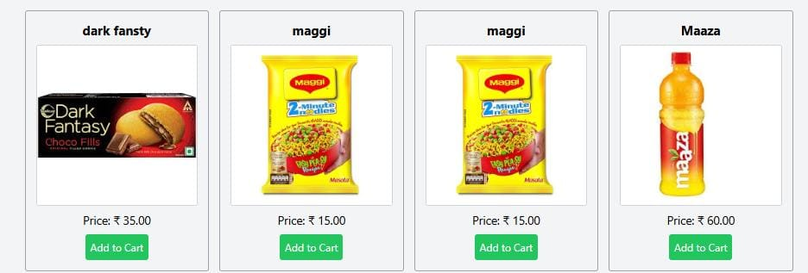

**Cart:**

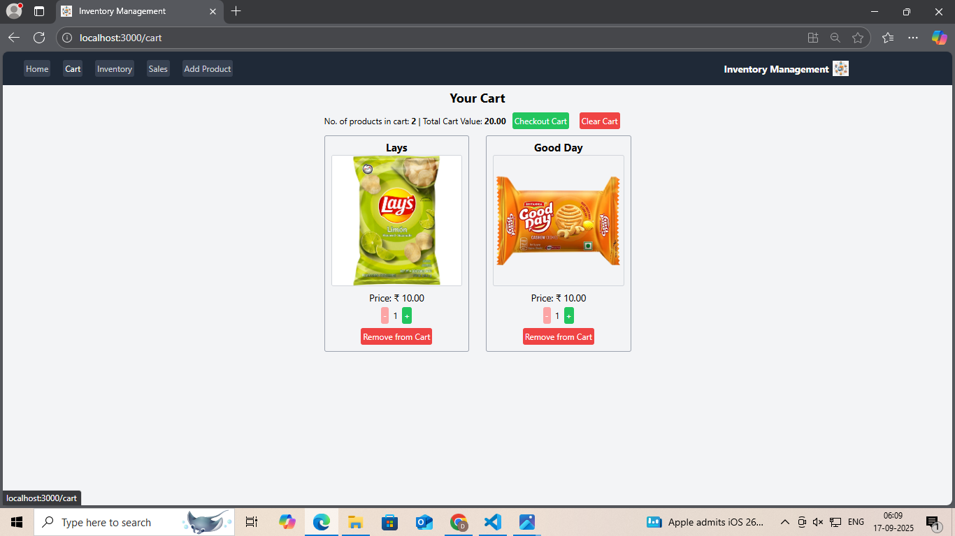

**Inventory:**

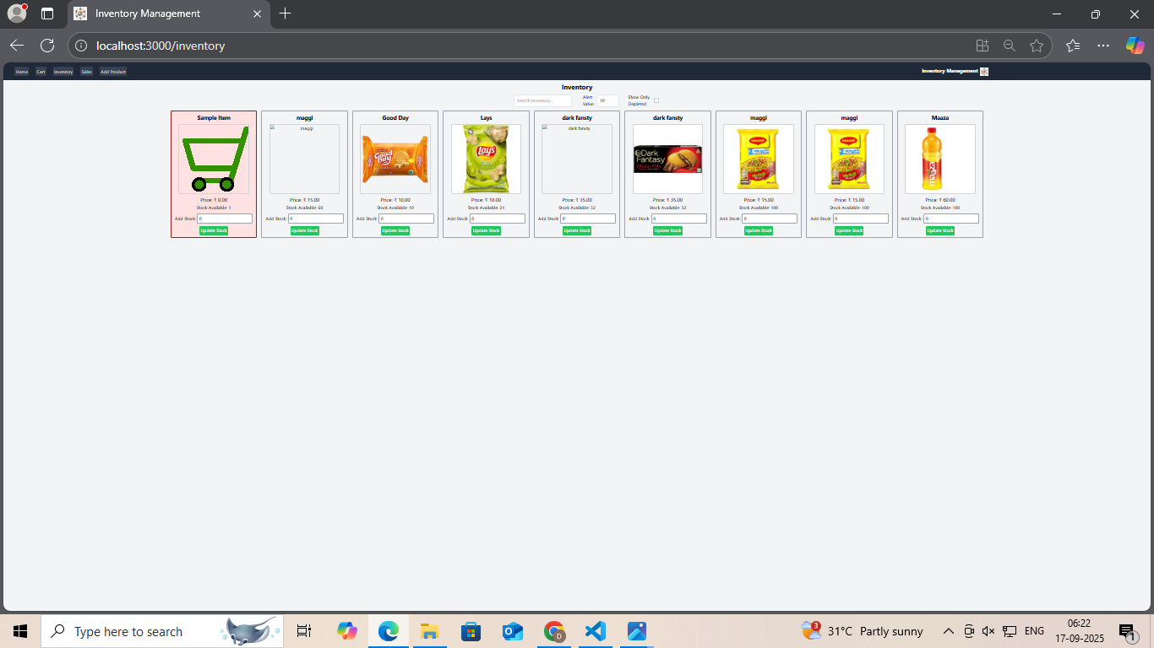

**Sales Record:**

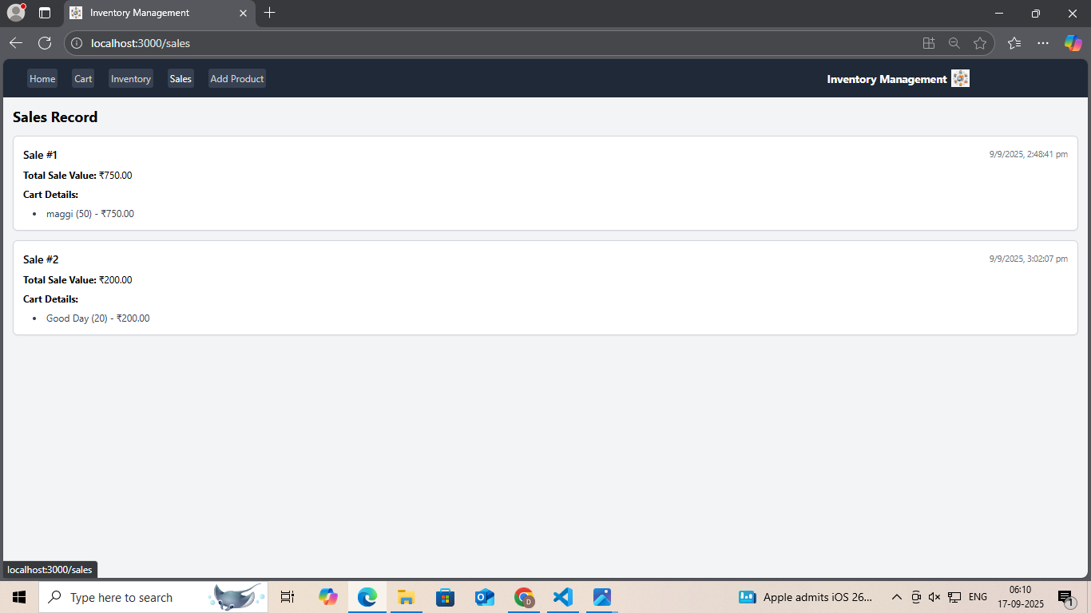

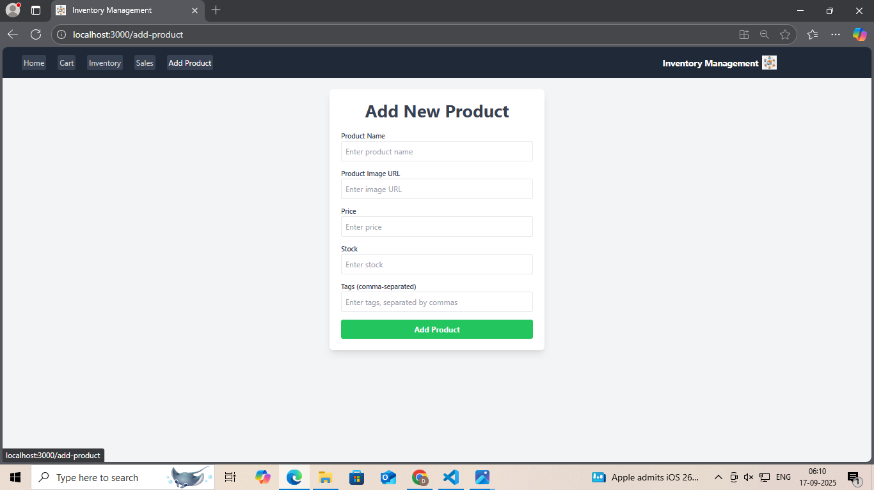**Add New Products :**

**12.KNOWN ISSUES**

1. Stockouts: Running out of stock due to inaccurate forecasting or supply chain

2. Overstocking: Excess inventory leading to unnecessary holding costs and potential waste.

3. Inaccurate inventory records: Discrepancies between actual and recorded inventory levels.

4. Inventory shrinkage: Loss of inventory due to theft, damage, or errors.

5. Poor supplier management: Delays, quality issues, or unreliable suppliers.

6. Inefficient inventory tracking: Manual errors, lack of visibility, or inadequate tracking systems.

7. Demand forecasting challenges: Accurately predicting demand due to seasonality, trends, or market fluctuations.

**13.FUTURE ENHANACMENT**

**Key Trends:**

1.AI and ML: Predictive demand forecasting, automated reordering, and optimized storage.

2. IoT: Real-time visibility of stock levels, product conditions, and warehouse activity.

3. Cloud-Based Solutions: Real-time visibility, remote access, and scalability.

4. Automation and Robotics: AGVs, AMRs, and cobots improve efficiency and reduce labor costs.

5. Sustainability: Eco-friendly packaging, reduced waste, and sustainable practices.

6. Real-Time Tracking: Improved decision-making and customer satisfaction.

7. Predictive Maintenance: Reduced downtime and improved efficiency.